**RASHTRASANT TUKADOJI MAHARAJ NAGPUR UNIVERSITY,**

**NAGPUR**

**Year 2016-17**

**POST GRADUATE DIPI.OMA**

**IN**

**(CLOUD TECHNOLOGY)**



**BY**

* + **ROSHAN .R. MARKHANDE [16]**
* **E-mail ID :-** [**markhande007roshan@gmail.com**](mailto:markhande007roshan@gmail.com)
* **Contact No :- 7719881186**
  + **SHUBHAM .P. PARATE []**
* **E-mail ID :-shubhamparate69@gmail.com**
* **Contact No :-**
  + **HARISH .T. DESHLAHARE []**
* **E-mail ID :-harishdeshlahare@gmail.com**
* **Contact No :-**
  + **KAMINI . NIMJE []**
* **E-mail ID :-**
* **Contact No :-**

**A**

**SYNOPSIS**

**ON**

**“MIND GAME FOR STUDENTS ON CLOUD PLATFORM”**

Submitted in partial fulfilment of the requirements of the Course of

**POST GRADUATE DIPI.OMA**

**IN**

**(CLOUD TECHNOLOGY)**



**BY**

* **ROSHAN .R. MARKHANDE [16]**
* **SHUBHAM .P. PARATE []**
* **HARISH .T. DESHLAHARE []**
* **KAMINI . NIMJE []**

**under the guidance of**

**Mr. Swadip Gagbhiye**

**DEPARTMENT OF CLOUD TECHNOLOGY**

**RASHTRASANT TUKADOJI MAHARAJ NAGPUR UNIVERSITY,**

**NAGPUR**

**Year 2016-17**

**“MIND GAME FOR STUDENTS ON CLOUD PLATFORM”**

**CONTENT**

**Abstract**

**Content**

**Chapter 1: introduction and cloud gaming……………..…… 1**

* 1. **Introduction**
  2. **What Is Cloud Gaming?**
  3. **So What Does the Cloud Mean for Gaming?**

**Chapter 2: Game development on AWS…..………………… 5**

**2.1 Global game server**

**2.2 Analytics**

**2.3 Core Game Backends**

**Chapter 3: Experimental work on Gaming……………………**

**3.1 Objective of Research in online Gaming**

**3.2**

**Chapter 4:**

**Chapter 1: The Best Cloud Gaming Services: Welcome Gaming to the Web**

**1.1: Introduction**

The wide-used of the cloud computing has led the gaming industry to a revolution that changes the way human play games. This up-and-coming technology called cloud gaming, also known as gaming on demand, is a concept that involves many of distributed computers connected through a synchronous communication network. The service of documents and file sharing has been altered in gaming industry to adjust the development of cloud gaming.

Cloud gaming is an innovative application that offers new opportunities for both upcoming and existing games based on cloud computing. Under the running mode of cloud gaming, all the games are stored in the operators’ or game company’s server so that direct streaming of video sequence onto electric devices such as computers and consoles over internet are allowed. The

thin client in low-end only gives requests to high-end server which deals with these requests and streams game experience back as a response. Games are held and run in remote servers so that no downloading is needed for client side and all updates are completed within these servers. Figure 1 shows the basic idea of cloud gaming.

Figure 1 basic idea for cloud gaming

As a result, cloud gaming liberates users from the need to necessarily update their devices and handles compatibility issues while accessing games from servers. Users do not need to master the functionalities and operation of infrastructure in a cloud or relevant professional knowledge. As an advantage, less powerful computation is required to run a high-quality game and offer great performance. [1] One of other advances is the cost of purchasing a gaming console or a high configuration computer to support a greater computational performance can be reduced. Furthermore, time is saved due to downloading, installing and updating are no more exist onto local host.

Over recent years, events surrounding this emerging technology have been successive occurred all over world; moreover, researches and exploitations are conducting and improving to expand advances in cloud technology to allow processing both traditional and complicated computation in an efficient way.

**1.2: What Is Cloud Gaming?**

[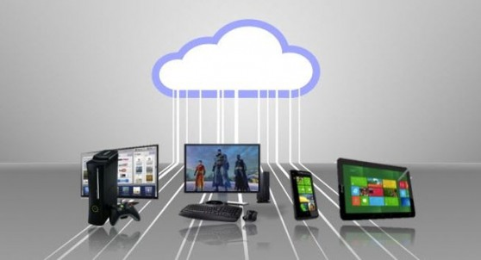](https://3thlkd3wpu0u1x0qbt19cxc8-wpengine.netdna-ssl.com/wp-content/uploads/2015/12/cloud-gaming.jpg) Cloud gaming, sometimes referred to as Gaming-as-a-Service, or [GaaS](https://www.cloudwards.net/understanding-cloud-terminology-what-does-iaas-paas-and-saas-mean/), is a relatively new way of playing games that takes advantage of the power of servers. Traditionally, you’d run a game on your expensive console or PC. In the case of cloud gaming, though, the game actually runs on a server owned by a gaming service.

You log into a client from your own computer and input controls with your keyboard and mouse or gamepad. The server receives your jumps and attacks, renders the game, then streams a video of the gameplay back to you. It’s more like [Netflix](https://www.cloudwards.net/best-vpn-for-netflix/) than [online gaming](https://www.cloudwards.net/is-online-gaming-safe/), basically.

Even a decade ago this would seem pretty far out. Running servers that were powerful enough would’ve been unrealistically expensive. Streaming high quality video would have consumed too much bandwidth. The delay between input and receiving video would have resulted in an unusable gaming experience.

But now, with decent internet, it’s possible to game with cloud based computers without ruining your gaming experience with latency (learn more about latency and gaming in this article on the [best VPN for gaming](https://www.cloudwards.net/best-vpn-for-gaming/)).

**Gaming-as-a-Service**

You may have heard the term gaming as a service before, but depending on where you heard it, it doesn’t necessarily mean what we’re talking about here. It has come to have two meanings in the gaming community: one is an emerging technology, the other is a widely unpopular business model that some video game publishers have been moving toward.

In the latter case, companies such as Ubisoft are building games with the expectation that players will [continue paying money](https://arstechnica.com/gaming/2018/02/keep-playing-keep-paying-ubisoft-seeks-games-with-longterm-engagement/) for things like DLC and loot boxes long after the initial purchase date to enjoy a game. Ultimately, this means that, as a player, you get less game for the same price you’re used to paying. You’ll then need to pay even more after release to get the full experience.

While we could publish a small text book about the ramifications of this transition, we’ll leave that subject to other publications like [*Kotaku*](https://kotaku.com/top-video-game-companies-wont-stop-talking-about-games-1795663927) and focus on what Cloudwards.net knows best: cloud based software.

**1.3: So What Does the Cloud Mean for Gaming?**[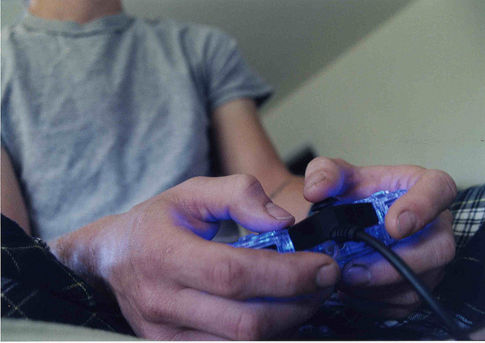](https://3thlkd3wpu0u1x0qbt19cxc8-wpengine.netdna-ssl.com/wp-content/uploads/2015/09/videogaming.jpg)

Gaming in the cloud rather than on expensive hardware might seem too good to be true, but there are some caveats. It’s promising, but not for everyone. The experience simply won’t be quite on par with a proper rig.

The first issue is that, although latency has been reduced to the point where cloud gaming can be usable, it’s still never going to be as low as running your own setup. Some cloud gaming services offer internet tests that will tell you exactly how much extra latency you can expect.

The second issue is that video needs to be compressed to be streamed to you. This is a key point when comparing services and is influenced by your connection speed. The faster your internet, the higher quality video services can send to you. A good service will take advantage of extra bandwidth and give you a better experience.

Another concern is the power of hardware. This varies widely between services and isn’t always comparable. Playstation Now will give you the power of a PS3 or PS4, depending on the title you’re playing. Some services advertise 4K capabilities, but most commonly the hardware will be about as powerful as a PS4 Slim, Xbox One S, or low-end gaming PC. Ultimately, you’ll get a better gaming experience on most home rigs.

The last issue is general clunkiness. Not all services are bad, but, as this is a new technology, many haven’t perfected the user experience yet. Interacting with a PC desktop from another PC desktop can come with some weird issues.

For example: you may be unable to alt-tab out of a game because it will simply move you away from the program giving you access to the streamed desktop. Some services don’t support game controllers. Most don’t support audio input for in-game chat.

**1.4 : Architecture**

A number of models have been conducted as there is no standard definition for the structure of the cloud gaming currently. Jiang W etc. agree that the architecture model of could game generally consist of two main parts: infrastructure and software computing system [3]. In the general cloud computing structure, as shown in Figure 3, PaaS locates in the middle layer where the upper layer is SaaS and lower layer is IaaS [7].

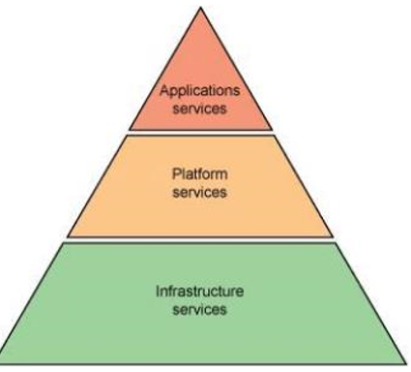

Figure 3. Layers in cloud computing

4.1. Hardware design infrastructure Hardware design infrastructure, also called infrastructure as a service (IaaS), is the foundation of the whole system and used to define the major structural modules as well as providing an environment for system analysis and computation. First of all, a group of connected servers are needed for cloud computing. In order to maintain the balance of the data loads between servers, computation is divided into pieces and allocated to every member in the cloud evenly. Compared to grid computing, infrastructure in cloud is more centralised and this minimises

the radiation problem. Secondly, for the purpose of meeting the need of constantly increasing information storage, ultra-capacity space plays a key component in cloud to match various memory requirements for both users and systems. Finally, cloud computing is based on the network computational model of Internet which involves frequently saving and exchanging data between numerous server groups and ultra-capacity spaces. Therefore, a high-speed broadband network is used to reduce effects of the latency to clients and improve the efficiency of communication as well as offering better performance [